Lecture 23, November 9, 2010 (Key Points)

23.1 Does the Flood Theory Generalize to Medium-size River Basins?
A great need exists to test the flood theory for RF-RO events in medium-size basins, from 500 to 50,000 km², or large basins > 50,000 km². Unfortunately, there are few basins having both a large number of streamflow gauges and accurate estimates of radar and rain-gauge-derived rainfall intensities, and most experimental basins are smaller than 500 km², like GCEW. The June 2008 Iowa floods caused more than $2B in damages, evacuated more than 30,000 people, and offered a rare opportunity to test the existence of power laws in peak flows for the Iowa River basin. This basin drains an area of approximately 32,400 km² and contains 29 USGS streamflow gauging sites. Radar-derived rainfall intensities in space and time are also available for this basin for 10 years, which would enable diagnostic tests of scaling in annual flood quantiles. Scientific objectives on medium and large basins pose challenges that are not present in GCEW such as need for accurate estimates of radar and rain-gauge-derived rainfall intensities in time and space that are explained below.

23.2 The Challenge of Dynamic Parametric Complexity in Predicting Floods in River Basins
We have already seen in Lecture 18 that the nonlinear geophysical scaling theory of peak discharges requires decomposing a river basin into hillslopes and channel links, as they exist on a terrain. A set of coupled ordinary differential equations representing mass and momentum conservation specify the processes of spatially variable infiltration and runoff generation on hillslopes, which derive from space-time variable rainfall intensity, and travel time dynamics in channel links. Solution of coupled Eqs. (18.6) and (18.7) gives a discharge hydrograph at each channel junction in a network and reflect accumulation of spatially variable runoff throughout a network. However, a very large number of dynamic hillslope-link scale dynamic parameters are required for solving the coupled differential equations. The number of parameters increases with the size of a basin. Let us explain this key issue.
Runoff intensity from each hillslope is produced by three distinct physical runoff-generation mechanisms. These are, (1) Hortonian infiltration-excess runoff, (2) saturated overland flow, and (3) subsurface storm flow, as explained in Lecture 14. We do not need such a detailed runoff-generation physical model for our purpose, and an idealized representation is sufficient (Menabde and Sivapalan 2001).
Consider an idealized bucket-type representation of processes governing runoff generation from a single hillslope, which requires four physical parameters. The first parameter is a threshold infiltration rate known as the ϕ index (Lecture 22), which in our context changes from one hillslope to another. Therefore, we use the notation to indicate this dependence a hillslope draining into a link ‘e’. The rainfall intensities produce Hortonian overland flow, from a hillslope, and the infiltration rate,
For rainfall intensities , there is no overland flow, and the infiltration rate is, . We will use a single “bucket” to do the subsurface water balance for a hillslope rather than two buckets corresponding to the unsaturated and the saturated zones. A more realistic physical model of runoff generation than a single bucket model is not required for our purpose. Infiltration becomes input to the single bucket representing the entire subsurface part of a hillslope. The outflows from the bucket are evapotranspiration to the atmosphere, and subsurface flow to the channel link. Evapotranspiration rate, at any time is assumed to be directly proportional to the current storage, , such that, , where the second parameter is a characteristic evapotranspiration time scale. Subsurface or base flow, is generated when the storage exceeds a threshold value, , which is the third parameter denoting field capacity for a hillslope (defined as the moisture in a soil after gravity drainage is complete). The base flow is proportional to the excess storage. , where , a characteristic base-flow time scale, is the fourth parameter.
The total runoff intensity from a hillslope is given by,

, (23.1)

We have assumed the rainfall rate, is uniform over the two hillslopes that drain into link e. Eq. (23.1) specifies the runoff rate from hillslopes into the channel link e in the network-based conservation Eqs. (18.6) and (18.7) (Lecture 18) reproduced below,

(23.2)

where,

(23.3)

The three physical parameters in Eq. (23.3), vary spatially among links.
The above discussion identifies a total of seven parameters to describe the physical processes of runoff generation and transport in a single hillslope-link system. Numbers of parameters increase beyond seven as some of the above idealizations are relaxed and more realistic hillslope-link based physical models are considered. However, for our purposes, it is sufficient to consider a minimal representation of the physical system to illustrate the dynamical complexity of rainfall-runoff transformations due to spatial variability of physical processes in a river basin.
The values of the seven physical parameters vary spatially among hillslopes and links through out a basin. This spatial variability produces a very large number of values of these parameters as the size of a basin increases. For example, the mean hillslope has a typical area of 0.05 km². Therefore, a basin of 1 km² can be partitioned into 1/0.05=20 hillslopes and 10 links. It gives, 20X4+10X3=110 different values to the seven parameters. We will call it the number of degrees of freedom (NDOF), because the complexity of physical processes in a drainage basin can be formally (but not physically) compared to microscopic molecular interactions in a statistical-mechanical system, which contains a very large NDOF. Above calculations lead to the formula that in a river basin of area A,

(23.4)

Equation (23.4) shows that the NDOF increases linearly with the drainage area, A. For example, NDOF is ~ 2300 in the 21 km² GCEW, and is ~ 3.6×10⁶ in the 32,400 km² Iowa River basin. Most of these parameters are not measurable, and no geophysical theory is available to specify them. Therefore, assumptions regarding the spatial variability of these parameters cannot be directly tested. Remote sensing can provide some of the spatially variable parametric information, especially as it pertains to channel network geometry, such as link length and slope. Specification of physical parameters is necessary for solving Eqs. (23.2) and (23.3). Gupta (2004) calls it the challenge of “dynamic parametric complexity”. The widespread use of calibration in rainfall-runoff models of engineering hydrology may be viewed as circumventing this challenge.

23.3 Tests of Scaling in the Iowa flood of June 2008
Gupta et al. (2010) analyzed the data collected at 29 USGS stream gauges upstream from Wapello, Iowa (Figure 23.1) to extract the maximum stream discharge values recorded in the period of May 29th to June 25th, 2008. These stream gauges measure discharges from watersheds with drainage areas varying from 6.6 km² to 32,374 km². Figure 1 also shows a set of selected 15-minute hydrographs at four gauging sites. A 30m DEM of the region provided by the USGS NED dataset (http://seamless.usgs.gov/index.php) was used to calculate upstream geomorphic properties for each site using CUENCAS. In particular, the upstream area and the peak of the width function were calculated. Historical peak discharge records were also obtained for each site from the USGS water website (http://water.usgs.gov).
Scaling plots for the peaks of the width function (Figure 23.2a), the hydrograph peak discharges for June 2008 flood event (Figure 23.2b), and the mean annual peak discharges (Figure 23.2c) for the 29 sites embedded in the Iowa River basin were constructed using the above information Gupta et al. (2010)). A standard linear least squares regression for the logarithms of the data was used to estimate the exponent and intercept of each of the three power law relations. In the case of the peaks of the width function, the power law relation is given by Q=2.07 A^{0.47}. For the June 2008 observed peak discharges, the power law relation is given by Q₂₀₀₈=1.38 A^{0.79}, and the relationship estimated for mean annual peak discharges is Q_{m}=3.68 A^{0.54}. The coefficient of multiple determination, R², of the log-log linear regression is 0.95 in all the cases. The excellent fit of the power law relations for both the flood event and the mean annual floods over four orders of magnitude variation in drainage areas is an unprecedented observation. It serves as a foundation to generalize and test the geophysical theory of floods in medium-sized basins as explained next.
Solution of differential Eqs. (23.2) and (23.3) under idealized physical conditions show asymptotic scaling in peak discharges versus drainage area that is reviewed in Gupta et al (2007). This body of literature furnishes the basis to state the central hypothesis of the scaling flood theory as follows:

Given a space-time variable rainfall intensity field corresponding to a RF-RO event, solutions of coupled mass and momentum conservation differential equations describing runoff generation and transport in a hillslope-link system in a self-similar river network produce spatial scaling relations between peak discharge and drainage area in the limit as area, .

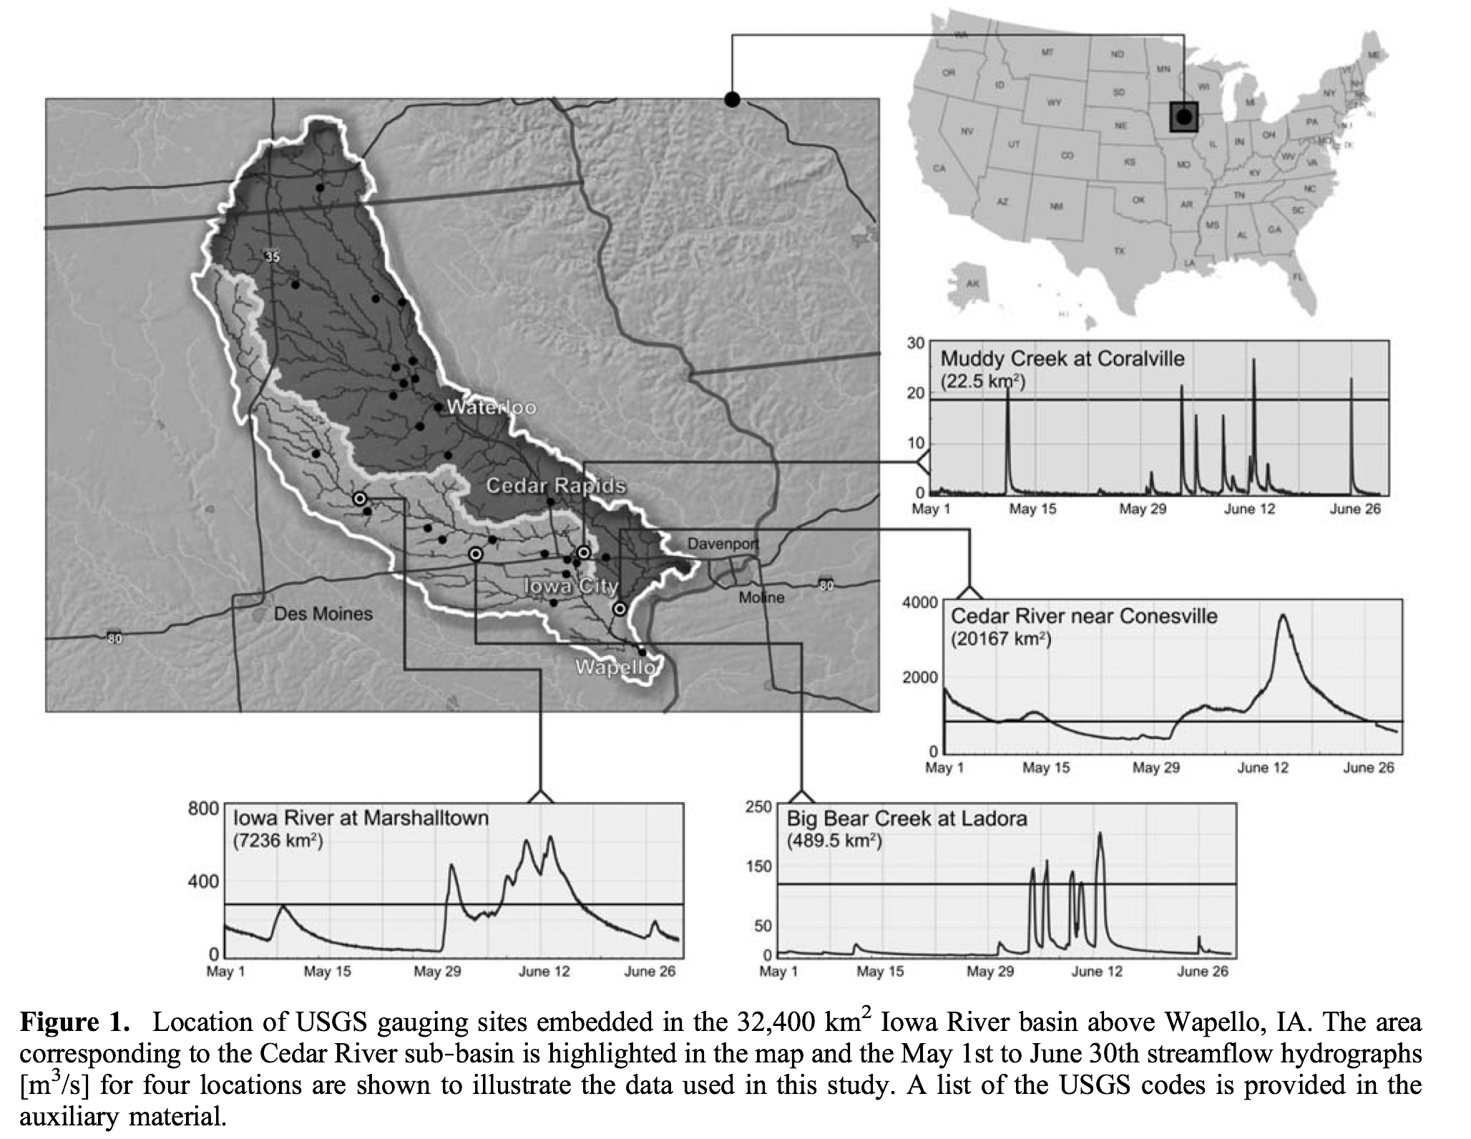
Figure 23.1 Locations of USGS Gauging stations in the Iowa river basin

In contrast to the space-time complexity of physical processes producing runoff at the hillslope-link scale, observations show that the aggregated behavior of peak flow statistics exhibits scale invariance or scaling in the form of power laws at successively larger spatial scales. Figure-23.2 illustrates the presence of power laws with respect to drainage areas in the peaks of the width function, individual rainfall-runoff events and in annual flood quantiles. Statistical scaling is an emergent property of a complex system, which a-priori is not built into the physical equations.

23.4 A formal analogy between Scaling in Floods and Statistical Mechanics
Statistical and other simplifying assumptions are necessary to reduce the NDOF for solving differential equations, but most of these assumptions cannot be directly tested against observations. Nevertheless, numerical or analytical solutions can be obtained for predicting scaling parameters. A discrepancy between physical predictions and empirically estimated values of the scaling parameters provides a rigorous theoretical
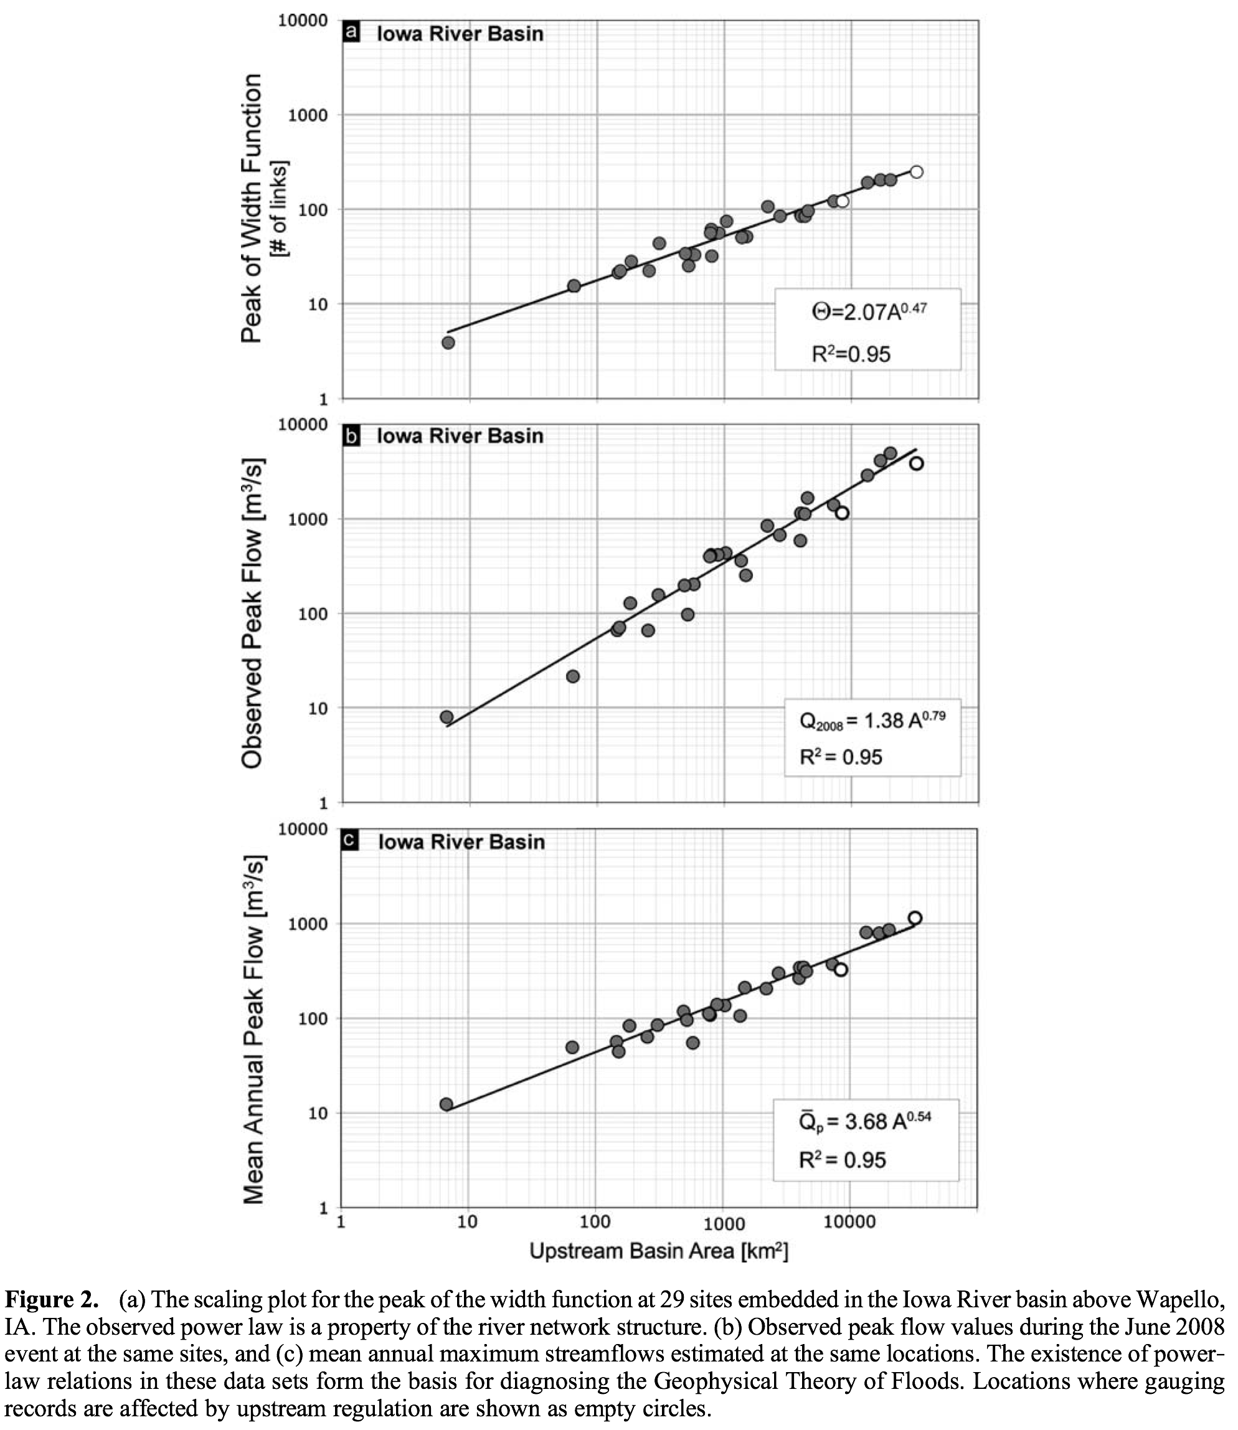
Figure-23.2 Observed power laws in the peaks of the width function, June 2008 flood event and in annual flood quantiles

framework to test different physical assumptions and to formulate and test new hypotheses without requiring calibration.
In summary, the scaling theory of floods attempts to understand the observable space-time scaling flood statistics from fundamentally unobservable physical processes at the hillslope-link scale. This interpretation is formally (but not physically) similar to how macroscopic thermodynamic parameters arise from microscopic statistical dynamical equations governing molecular motions. Indeed, Gupta and Waymire (1983) had put forward the idea that dynamic hydrologic complexity in a river basin can be compared to the complexity of a statistical-mechanical system. In this sense, the goal of the scaling theory of floods is similar to the goal of deriving macroscopic thermodynamic parameters from microscopic statistical physics. The flood problem is one of many other multi-scale problems that arise in geophysical, physical, engineering, biological, and social sciences.

23.5 The Grand Hydrologic Challenge of Predicting Scaling in Floods
Fig. 23.2a shows self-similarity in the channel network of the Iowa River basin that the theory requires (Veitzer and Gupta 2001). Fig. 23.2b shows scaling in peak discharges versus drainage areas as stipulated above by the central hypothesis. The diagnostic power of the observed scaling can immediately be seen in comparing the relations in Figures 23.2a and 23.2b. The discrepancy in slopes would lead to a rejection of at least one of the three assumptions underlying width-function GIUH: (W1) inputs to the river network are spatially uniform, (W2) inputs occur over a short period of time, and (W3) water moves through the network at a constant velocity without attenuation. So, new physical assumptions are needed to predict scaling in June 2008 flood in the Iowa River basin that can be tested against Figure 23.2b. It is intriguing to note that the slope in Fig. 23.2b (0.79) is close to the average for individual events in GCEW (0.82) (Ogden and Dawdy, 2003), despite huge difference in the range of drainage areas. The grand geophysical challenge of predicting the two scaling parameters, and solving the problem of dynamic parametric complexity, requires a “physical-statistical ensemble framework”, as explained next.
Furey and Gupta (2007) used solutions of conservation equations and physical parameterizations to simulate discharge hydrographs at each of the 552 channel junctions in GCEW (Lecture 21). An ensemble of hydrographs was used in constructing a ‘conditional mean response function’ for predicting flood-scaling slopes and intercepts (Lecture 22). Random self-similar network (RSN) framework would allow simulating multiple ensembles of hydrographs for conducting rigorous diagnostic statistical analyses in a basin, but the RSN model is beyond the scope of this course.
Furey and Gupta (2007) constructed a second ensemble of time series of ‘rainfall minus infiltration intensities’ of different durations that was needed in predicting scaling slopes and intercepts (Lecture 21). They used rain gauge measurements and ignored spatial rainfall variability in a small basin. By contrast, a generalization of the flood theory to medium-sized basins requires an ensemble of space-time variable rainfall fields. During the 2008 Iowa flood episode an analysis of the radar-derived rainfall fields indicates that the storms associated with the floodwaters covered the entire basin, although at different times and different locations (Gupta et al. 2010). A huge literature has accumulated in the last thirty years on space-time rainfall. Lectures 24, 25 and 26 will be devoted to briefly introducing this body of literature.
The third ensemble represents dynamics of floods in a channel network in medium and large basins that explicitly incorporates space-time variability in link velocity. It requires an introduction to the literature on hydraulic-geometry in river networks. Lectures 27 and 28 will be devoted to this important topic.
There is no published literature on specifying the hillslope parameters governing runoff generation from a large number of hillslopes. It is an important topic of current research.
A physical understanding of scaling in mean annual floods shown in Figure 2c requires an analysis of scaling in multiple RF-RO events for multiple years. Based on the results for GCEW (Ogden and Dawdy 2003) and Furey and Gupta (2007), one expects that scaling slopes and intercepts vary from one RF-RO event to another in the Iowa basin. This observational feature will be required in future theoretical investigations to predict the slope and intercept in Figure 2c, and in other quantiles, from scaling in multiple RF-RO events. Lectures 29 and 30 will be devoted to this important topic.

5. Closing Remarks
In a changing climate due to global warming, self-similarity in river networks would not change. Therefore, we infer that the power laws in peak discharges at event and annual time scales would remain intact. Will global warming change the structure of rainfall intensity and duration? What will that change be (Dawdy 2007)? Will it change the frequency of thunderstorms or net precipitation producing floods that directly affect scaling slopes and intercepts for RF-RO events (Furey and Gupta 2007)? Regardless of the change, a physical understanding of slopes and intercepts is necessary to predict peak discharges in a changing climate at multiple spatial locations and at time scales ranging from hours and days of a single event to annual flood frequency involving multiple events. It is an important topic for current hydrologic research!

References

Dawdy, D. R., Prediction versus understanding (The 2006 Ven Te Chow Lecture), Journal of Hydrologic Engineering, 12(1), 1–3, 2007.

Furey, P. R., and V. K. Gupta, Diagnosing peak-discharge power laws observed in rainfall-runoff events in Goodwin Creek experimental watershed, Advances in Water Resources, 30, 2387-2399, 2007.

Gupta, V. K., Emergence of statistical scaling in floods on channel networks from complex runoff dynamics, Chaos, Solitons & Fractals, 19(2), 357–365, 2004.

Gupta, V. K., B. M. Troutman, and D. R. Dawdy, Towards a nonlinear geophysical theory of floods in river networks: An overview of 20 years of progress, in Nonlinear Dynamics in Geosciences, edited by A. A. Tsonis and J. B. Elsner, pp. 121–151, Springer, New York, NY, 2007.

Gupta, V. K., Mantilla, R., Troutman, B. M., Dawdy, D., and Krajewski, W. F., Genera-lizing a Nonlinear Geophysical Flood Theory to Medium-Sized River Networks, Geophy. Res. Letters, V. 37, L11402, doi:10.1029/2009GL041540, 2010.

Gupta V. K., and E. Waymire, On the formulation of an analytical approach to hydrologic response and similarity at the basin scale, In: Scale Problems in Hydrology, (Ed. I. Rodriguez-Iturbe and V. Gupta), J. Hydrology, 65: 95-123, 1983.

Menabde, M., and M. Sivapalan, Linking space-time variability of rainfall and runoff fields on a river network: A dynamic approach, Adv. Water Resources, 24, 1001–1014, 2001.

Ogden, F. L. and D. R. Dawdy, Peak discharge scaling in a small Hortonian watershed, Journal of Hydrologic Engineering, 8(2), 64-73, 2003.

Veitzer, S., and V. K. Gupta, Statistical self-similarity of width function maxima with implications to floods, Adv. Water Resources, 24, 955–965, 2001.

